Cv & caption

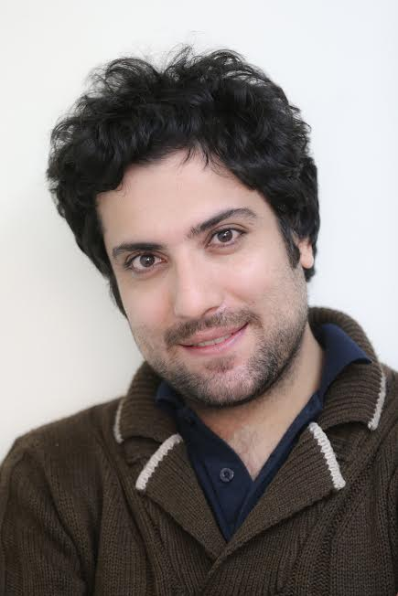

I am Adel Pazyar.

I m a Iranian freelance photographer based in Tehran, Iran . My projects focuses on social issues in Iran have been exhibited in various festivals around the world. In 2004 I became a member of “IRNA AGENCY”

I got into photography in 2003 and taught myself auto didactically and by working sporadically with local outlets from 2004 on. In late 2004 I started studying photojournalism and journalism at the University of School Of Media Studies in Tehran, Iran. my work has been on display in several group exhibitions in Paris, Bavaria , Tehran.

Awards and Honors

2016 nomination JOOP SWART MASTERCLASS WORLD PRESS PHOTO

2015 Documentary Winner of the HUMANITY PHOTO AWARDS (HPA)

2015 1st Prize of Andrei Stenin International Press Photo Contest

2015 1st prize of life press Foto National University "Ostrog Academy"

2014 Silver Medal in the 10th CHIPP contest

2013 golden medal Asahi Shimbon

2012 1st press festival in iran

SECTION I

The vague

Eighteen is not only number in Iran, it's sign of death for couple of criminal children that are waiting to loose their life. They are already condemned to death but execution lay off and they must be until they reach legal age. The mysterious walls and doors here are full of hidden buried secrets, full of stories of love, anger, and revenge. In the far reaches of these children's minds, a light is flickering to an future with lots of fear and hope. Every night dream stories end in the ones of forgiveness back home or the nightmares of death

SECTION II

Born of die 80% of the genes of humans and mice are the same and 90% of genes that cause diseases are also common between human and mice. On the other hand, mice's small size, high reproduction, and low maintenance costs have caused that thousands of mice around the world are born to die in laboratories every day.

Laboratory mice are infected with diseases viruses such as AIDS virus, Zika, Ebola, cancer, etc., to sacrifice for science on the path of human survival.

.